Let's Meet

Group ID: 05

3005 – Jaishil Bhavsar

3036 – Zeel Modi

3186 – Bhargavi Jansari

**Index**

**Chapter 2: Proposed System Requirement Gathering1**

2.1 Stakeholder Of System2

2.2 Requirement Gathering Technique Used4

2.3 Consolidate List of Requirement14

2.4 Project Definition15

# [**2.1**]Stakeholder of System

Stakeholders can be defined as “anyone who has an interest in system to be built”. Stakeholders may include individuals and groups of people who have some direct interest in the event’s planning, production and implementation or in participating in. Following are the Stakeholders of our System:

* Admin
* Event Organiser
* Participants
* Community
* User

1. Admin:
   * Admin is a person who is responsible for verifying and validating the events that are going to happen.
   * He or she manages meet the needs of the user.
2. Event Organiser:

* He is the person who organises the event to provide people of his interest to know more about their field.

1. Participants:

* Participants can be speakers, attendees, fans, visitors who attend event to explore something.
* Without the present of participant an event is impossible so there must be participants to attend an event.

1. Community :

* Local community includes indigenous people, NGOs, network, environmental groups.
* Here user can discuss also about problems.

1. User :

* The main objective of the system is to provide information of nearby events to the user so that all the events are placed on a single platform and doesn’t have to waste time in search of events on another platforms.
* A user is a person who makes bond with the system and take benefits provided by the system.
* User can give feedback for the system.

# [2.2]Requirement Gathering Technique Used

Requirements elicitation is the process to find out the requirements for a proposed system by communicating with end-users, client, system-users and other who have a stake in the system development.

There are various ways to discover requirements:

1. Interviews :

* Interviews are strong medium to collect requirements. Organizations may conduct several types of interviews such as:
  + Structured(closed) Interviews
  + Non-structured(open) Interviews
  + Oral Interviews
  + Written Interviews
  + One-to-one Interviews
  + Group Interviews

1. Surveys :

* Organizations may conduct surveys among various stakeholders by querying about their expectation and requirements from the upcoming system.

1. Questionnaires :

* A document with pre-defined set of objectives questions and respective options is handed over to all stakeholder to answer, which are collected and then compiled.
* A shortcoming of this technique is, if an option for some issue is not mentioned in the questionnaire, the issue might be left unattended.

1. Task Analysis :

* Team of engineers and developers may analyse the operation for which the new system is required. If the client already has some software to perform certain operation, it is studied and requirements of proposed system are collected.

1. Domain Analysis :

* Every software falls into some domain category. The expert people in the domain can be a great help to analyse general and specific requirements.

1. Brainstorming :
   * An informal debate is held among various stakeholders and all their inputs are recorded for further requirements analysis.
2. Prototyping :
   * Prototyping is building user interface without adding detail functionality for user to interpret the features of intended software product. It helps giving better idea of requirements.
   * The prototype is shown to the client and the feedback is noted. The client feedback serves as an input for requirement gathering.
3. Observation :
   * Team of experts visit the client’s organization or workplace. They observe the actual working of the existing installed systems. They observe the workflow at client’s end and how execution problems are dealt.
   * The team itself draws some conclusions which aid to form requirements expected from the software.

For our system we have used Questionnaire so that we can have wide range of idea of the needs of our stakeholders.

We have given different Questionnaires to different stakeholders. We want to know what they need in proposed system.

For the Users the following Questionnaire form is prepared:

1. Do you regularly like attending Webinars, Seminars, Work-shops, Book Launches, etc.?
   * Yes
   * Sometimes
   * No

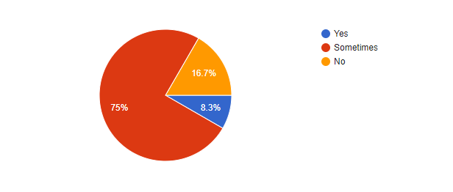

1. Are you using any system to get notified about events? If yes, then which is it?
   * Yes. Please specify_____________________
   * No

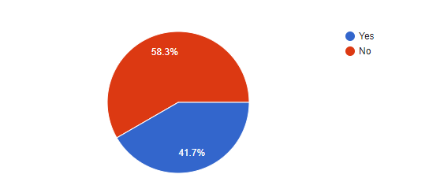

1. How would you like to get registered to our website?
   * Social Media
   * Manual Signup

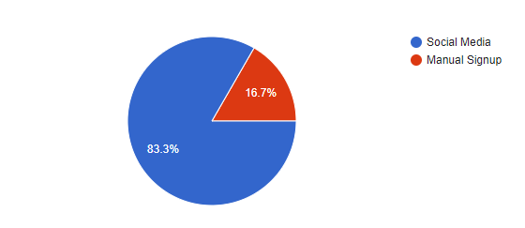

1. How would you like to be notified about events?
   * E-mail
   * System Notification
   * SMS

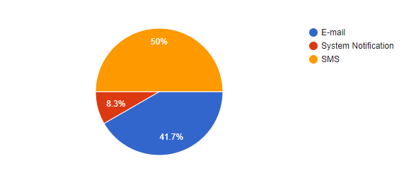

1. Which configuration method you prefer?
   * SMS
   * E-mail

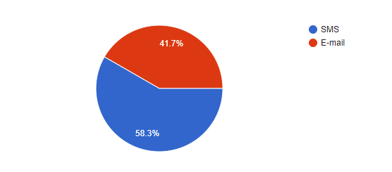

1. Do you know any event agencies? If yes then please specify.
   * Yes. Please specify_____________
   * No

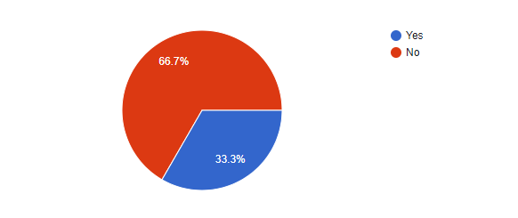

1. Would you like to use our services in future regarding events?
   * Yes definitely
   * Not at all. Please specify_____________

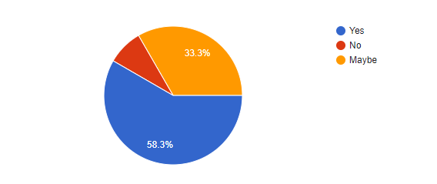

For the Event Organisers the following Questionnaire form is prepared:

1. Normally how you promotes your events?
   * Radio
   * Social Networking
   * Roadside Banners
   * Newspapers
   * Application

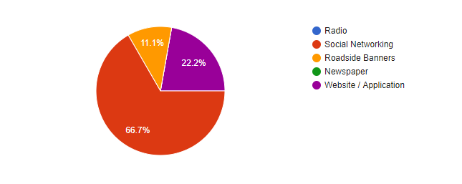

1. What kind of audience are you expecting?
   * Professional
   * Student
   * Others. Please Specify_____________

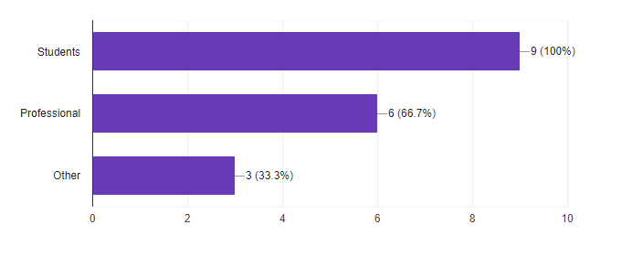

1. Do you get a good amount of audience for your event?
   * Yes
   * Average
   * Poor
   * No

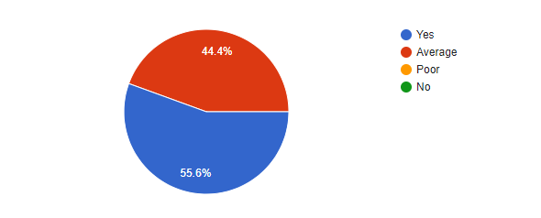

1. Will there be tickets for events?
   * Yes
   * No

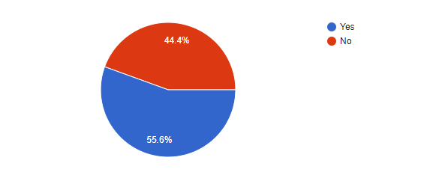

1. Do you take feedback for your events?
   * Yes
   * No

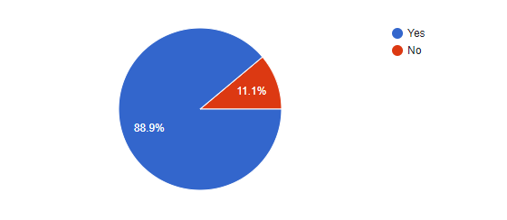

1. Would you like to promote your events by our system?
   * Yes
   * Maybe
   * No. Please specify reason___________

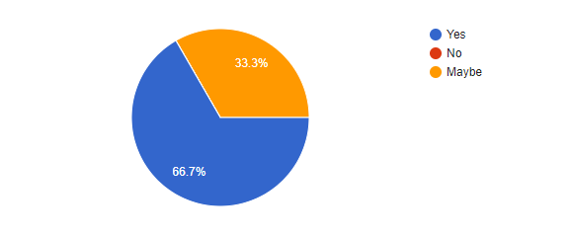

# [2.3] Consolidated List of Requirement

By taking Questionnaire we have decided to make following change in our system:

Users:

* Users need to login from Social Media rather than manual Signup, which saves their time and effort for remaining passwords.
* They wants to be notified by application notifications,
* They prefer SMS authentication over E-mails.
* They need all the types of event happening in city on a single platform.

Event Organisers:

* Organisers need a platform where they can attract a good amount of audience for their events.
* They need a feedback about their event so that they can improve it in future.

# [2.4]Project Definition

Hundreds of events happens in our city, but it’s difficult to find them out. ‘Let’s Meet’ in City helps you do that..!!Our System provides a common platform to people to do more of what they want to do in life. It is organized around one simple idea: “when we get together and do the things that matter to us, we’re at our best.” And that’s what our system does. It brings people together to do, explore, teach and learn the things that help them come alive.